- CREATING An Environment – One time step!!
- Check if you have conda installed in ENV path
Typing conda in VS Code terminal should show this.. it means conda is addted as env path:

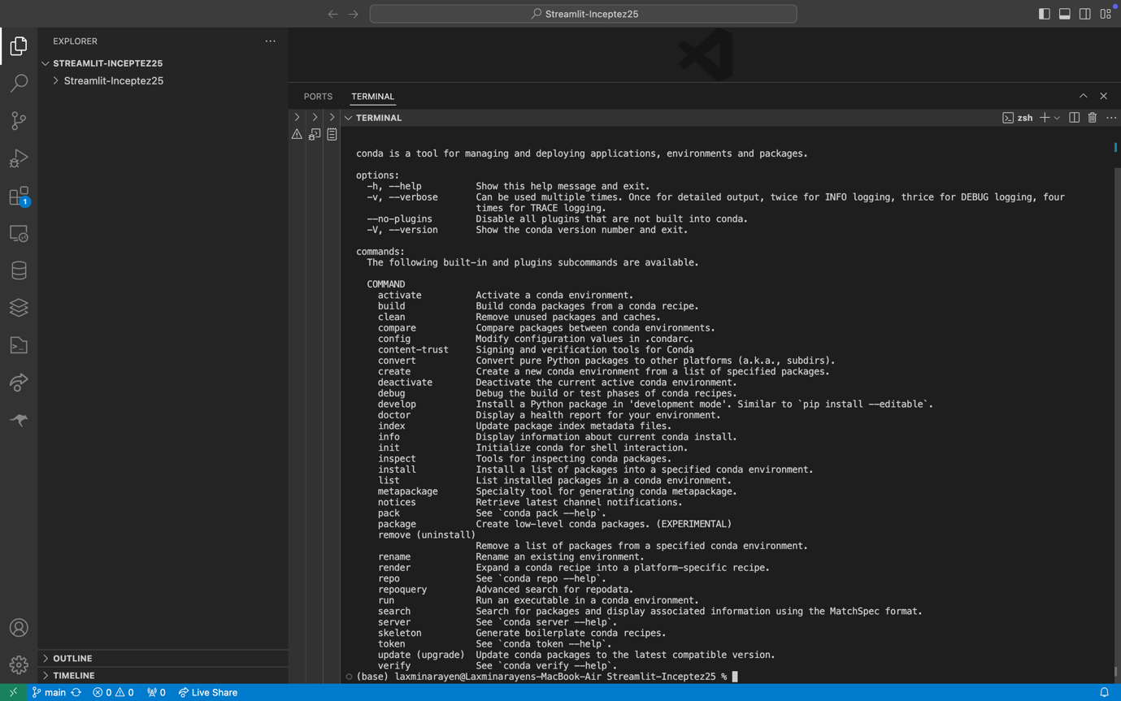

If not work with Anaconda Prompt!!!

- Create Conda env (ONCE CREATED IT WILL STAY!)
  - conda create -n <env_name> python=<version>
conda create -n streamlit_env_batch25python=3.9

- Check if exsist:
  - conda env list

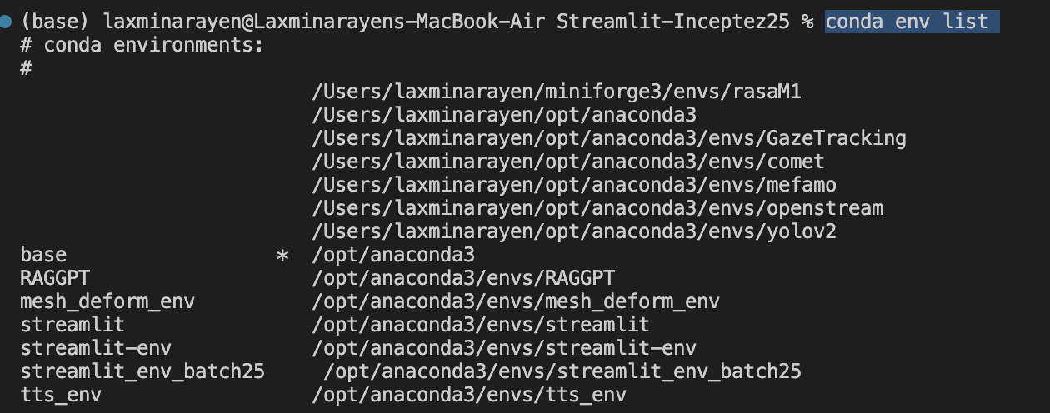

Add Requirements.txt: https://github.com/Laxminarayen/Streamlit-Inceptez25/blob/main/requirements.txt

- Navigate to the place where requirements.txt is present from the prompt.. and make sure it is present there..

And then do

- pip install -r requirements.txt

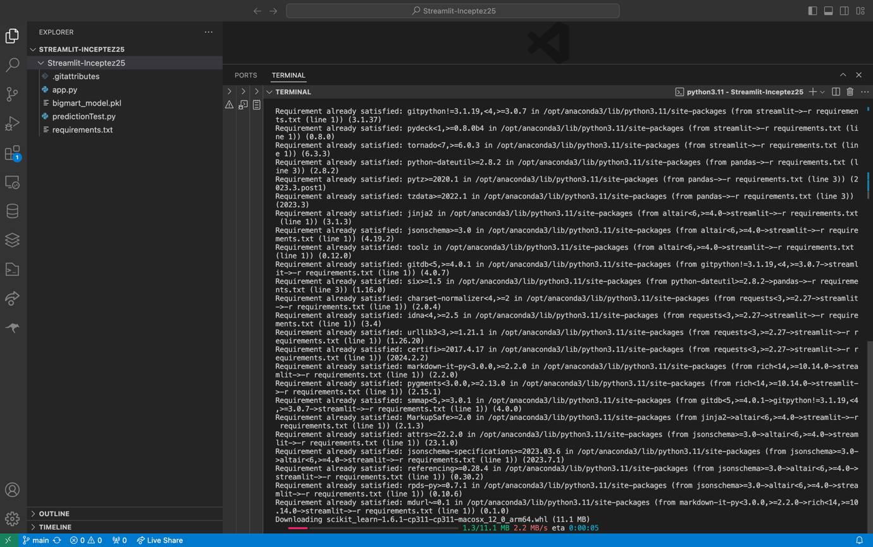
Once installations are done.. do from the same directory where you also have app.py
- streamlit run app.py

